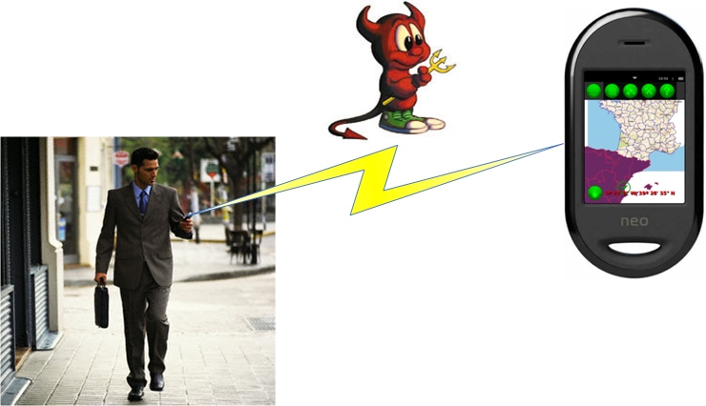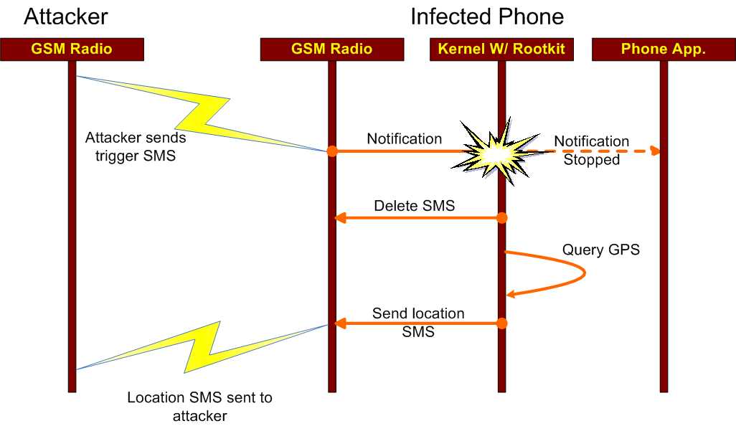
GPS Tracking Attack
Phone receives SMS from attacker
•
•
Rootkit blocks SMS alert

Location sent to attacker

•

